NAAN MUDHALVAN

TITLE : LOGO CREATION

USER NAME : 51834AAAE5148BD8EF94A7CB717881E6

1.Open canva 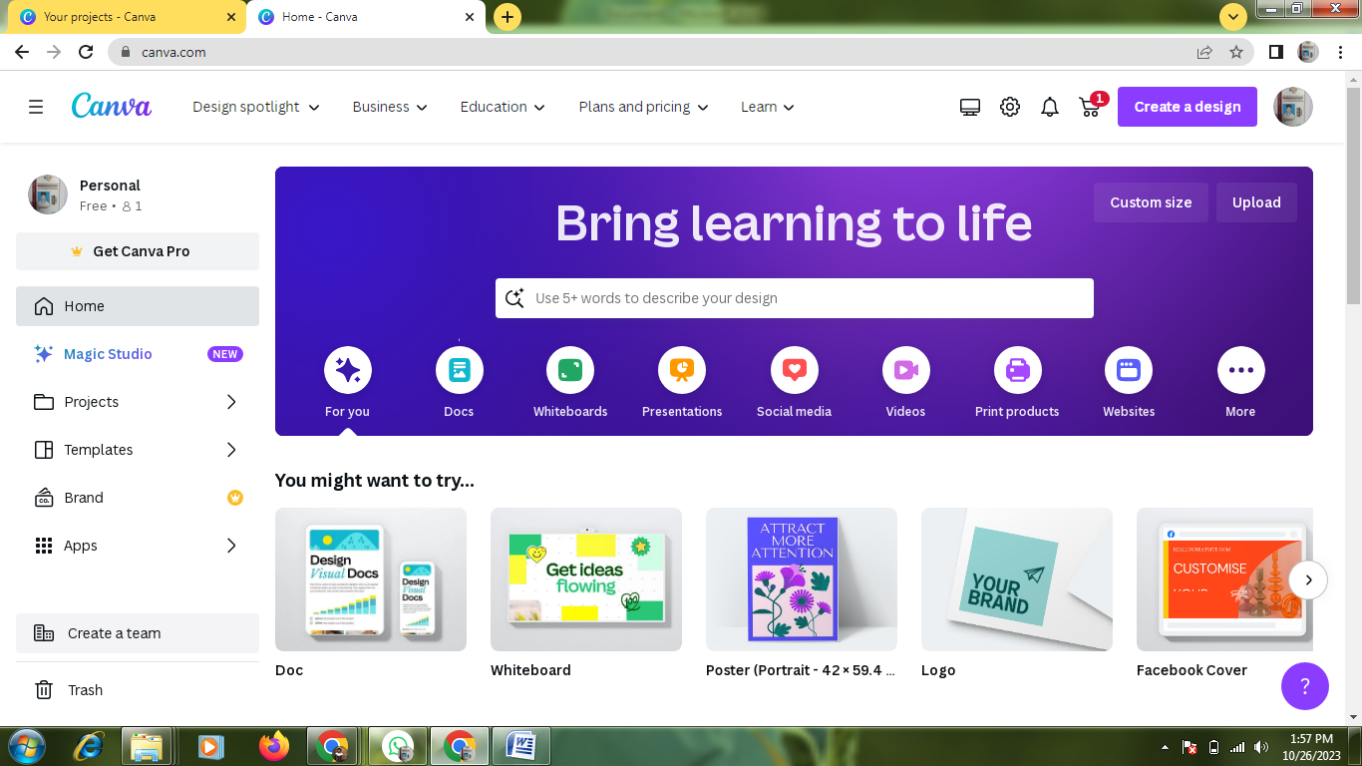

2.select a template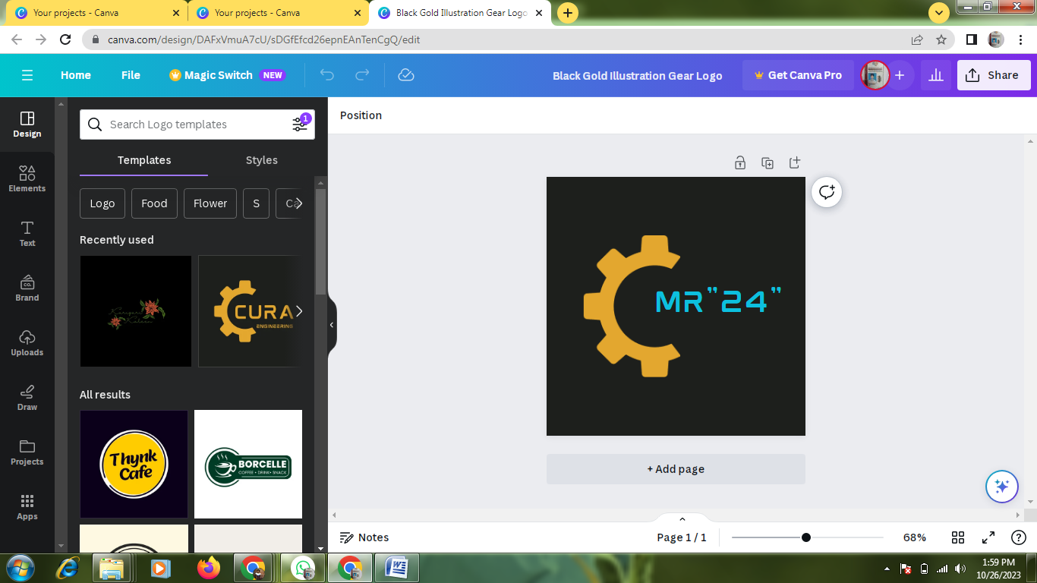

3.Edit a details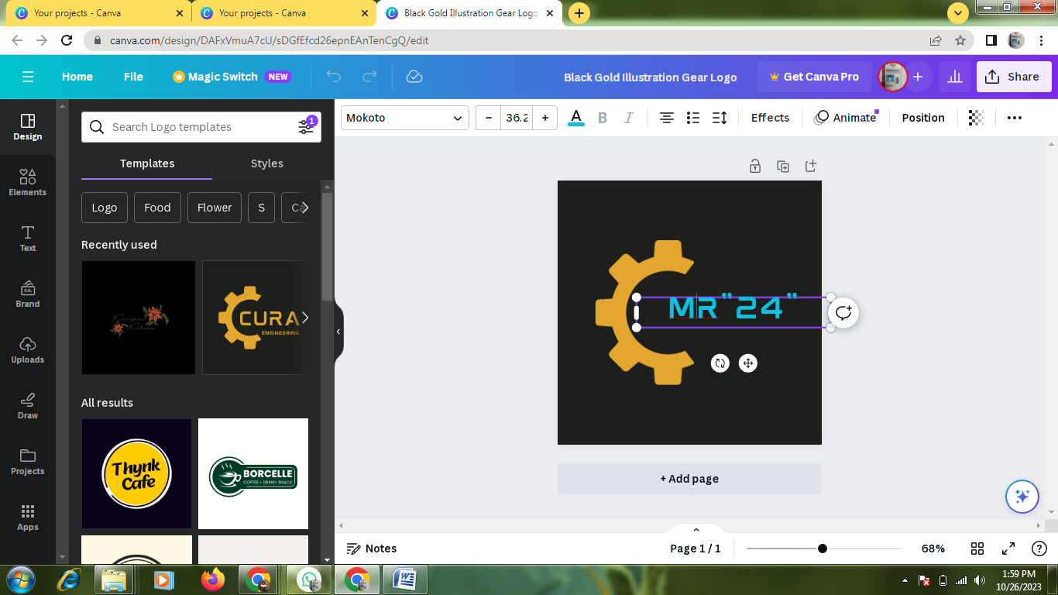

4.Pdf covert